Hi Kenny, hi Daniela

There were fun videos and Professor Muotri is entertaining to watch and he seems very passionate about his research. He is also, very convincing about the potential of brain organoids to answers fundamental questions. Among them, he mentions “brain disorder and how to restore loss function”, but before that, the one question, we can ask ourself, is how using organoids we can recreate the neural development stages of this disorder and how organoids can help to identify abnormal brain development.

Brain organoids can mimic the spatial and temporal patterning events observed in brain development. And as they grow, they show self-organizing structures exhibiting various brain region identities of the CNS. As the culture mature, the brain organoids can form dendritic spines and sprout into neuronal networks, modeling mature astrocytes, and also degeneration beyond development stage.

Research using brain organoids have already achieved remarkable results:

* **Microcephaly** - Seckel syndrome with microcephaly is caused by mutation of the CPAP protein and abnormal cilium disassembly complex (CDC), was detected for cells in brain organoids of a Seckel syndrome patient.
* **Macrocephaly**. - Li.Y and al. showed deletion of PTEN gene, resulted in size increase of cerebral organoids.
* **Autism** - Wang et Al., 2017, investigated the function of CHD8 protein (chromodomain helicase DNA-binding protein 8) in autism with CHD8+/- cerebral organoids, showing that genes like DLX6-AS1, which regulates the inhibitory GABAergic neurons displayed in autism were expressed (DEGs genes).
* **Psychiatric disorders** - DISC1 gene is associated with psychiatric disorders, such as schizophrenia, bipolar disorder, and depression: DISC1 and its binding domain Ndel1 causes various deficits which were confirmed in organoids derived from a schizophrenia patient with DISC1 mutation disrupting its interaction with NDel1.
* **Zika Virus** -Zika virus causes congenital microcephaly and disorder. Brain organoids models have shown that ZIKV infect cortical neural progenitor cell proliferation. Also, ZIKV infection of brain organoids have shown that the virus reduces cell proliferation and premature differentiation of glial cells and abnormal positioning of newborn neurons.
* **Prenatal drug exposure** - Using neocortical organoids, demonstrated that prenatal cocaine causes premature neuronal differentiation and interrupts the development of neural tissues.
* **Rett Syndrome** – is a neurodevelopmental disorder predominantly caused by mutations of the MECP2 protein. In both MeCP2-deficient and patient-derived organoids show defects in neurogenesis and neuronal differentiation.
* **Miller-Dieker Syndrome** – is a congenital disorder leading to brain malformations. Observations of MDS patient-derived organoids, researchers found new insights related to a mitotic defect of radial glia.

Many other organoids-based models have revealed significant neural factors and causes for neurodegenerative diseases like Alzheimer or Parkinson diseases. And although these models made very powerful discoveries, further improvements are needed:

* **Reproducibility**:” batch-effects”: reduce current high variability indifferent batches of organoids
* **Vascularized organoids**: absence of vascularization makes difficult to replicate correct cortical plat formation in brain organoids and also leads to apoptosis, also important to model blood-brain barrier.
* **Integration of non-neural cells**, such as microglia
* **More complex brain tissues**
* **More complex brain interactions** such as neuron-glia.

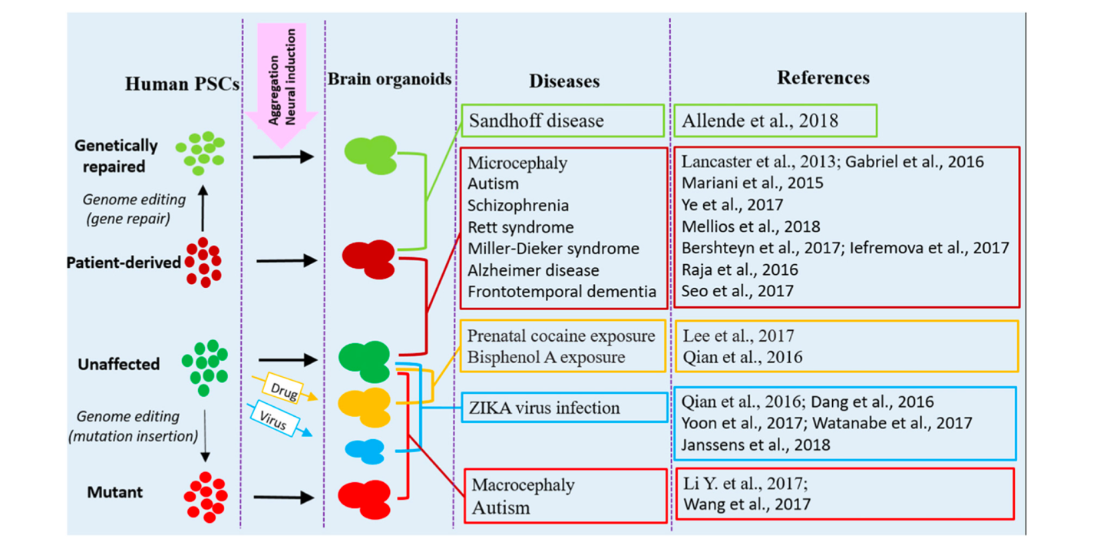

Human brain organoids modeling of neurological diseases

1. Giorgia Quadrato, Cell diversity and network dynamics in photosensitive human brain organoids, doi:10.1038/nature22047
2. Gabriel, E., Wason, A., Ramani, A., Gooi, L. M., Keller, P., Pozniakovsky, A., et al. (2016). CPAP promotes timely cilium disassembly to maintain neural progenitor pool. *EMBO J.* 35, 803–819. doi: 10.15252/embj.201593679
3. Li, Y., Muffat, J., Omer, A., Bosch, I., Lancaster, M. A., Sur, M., et al. (2017). Induction of expansion and folding in human cerebral organoids. *Cell Stem Cell* 20, 385.e3–396.e3. doi: 10.1016/j.stem.2016.11.017
4. Wang, H., and Doering, L. C. (2015). Autism spectrum disorders: emerging mechanisms and mechanism-based treatment. *Front. Cell. Neurosci.* 9:183. doi: 10.3389/fncel.2015.00183
5. Mellios, N., Feldman, D. A., Sheridan, S. D., Ip, J. P. K., Kwok, S., Amoah, S. K., et al. (2018b). MeCP2-regulated miRNAs control early human neurogenesis through differential effects on ERK and AKT signaling. *Mol. Psychiatry* 23, 1051–1065. doi: 10.1038/mp.2017.86
6. Bershteyn, M., Nowakowski, T. J., Pollen, A. A., Di Lullo, E., Nene, A., Wynshaw-Boris, A., et al. (2017). Human iPSC-derived cerebral organoids model cellular features of lissencephaly and reveal prolonged mitosis of outer radial glia. *Cell Stem Cell* 20, 435.e4–449.e4. doi: 10.1016/j.stem.2016. 12.007
7. Dang, J., Tiwari, S. K., Lichinchi, G., Qin, Y., Patil, V. S., Eroshkin, A. M., et al. (2016). Zika virus depletes neural progenitors in human cerebral organoids through activation of the innate immune receptor TLR3. *Cell Stem Cell* 19, 258–265. doi: 10.1016/j.stem.2016.04.014
8. Lee, C. T., Chen, J., Kindberg, A. A., Bendriem, R. M., Spivak, C. E., Williams, M. P., et al. (2017). CYP3A5 mediates effects of cocaine on human neocorticogenesis: studies using an *in vitro* 3D self-organized hPSC model with a single cortex-like unit. *Neuropsychopharmacology* 42, 774–784. doi: 10.1038/npp.2016.156
9. Raja, W. K., Mungenast, A. E., Lin, Y. T., Ko, T., Abdurrob, F., Seo, J., et al. (2016). Self-organizing 3D human neural tissue derived from induced pluripotent stem cells recapitulate Alzheimer’s disease phenotypes. *PLoS One* 11:e0161969. doi: 10.1371/journal.pone.0161969